**Installing Scratch Desktop**

1. Download the installer from this location

<https://scratch.mit.edu/download>

Note: You can download either the version for Windows 10+ or MacOS 10.13+

1. Select Direct Download to download either the .exe or .dmg file
2. For Windows installation, run the .exe file.

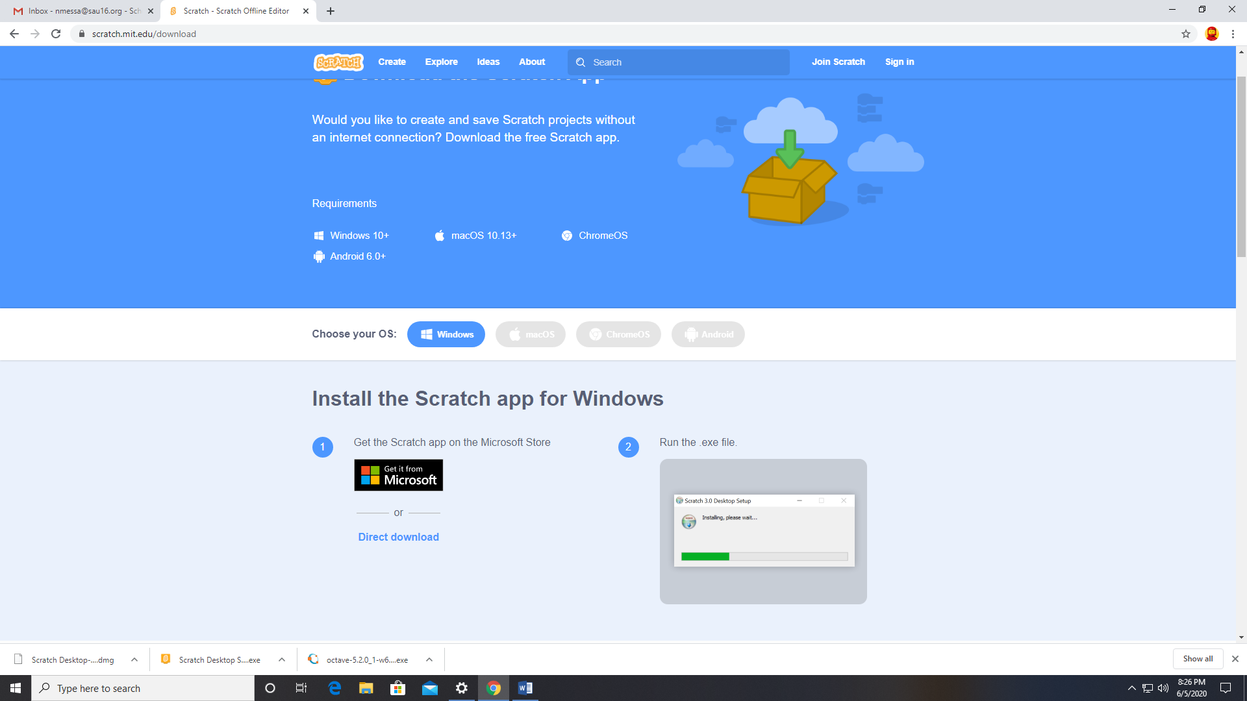

1. For MacOS installation, open the .dmg file and move Scratch Desktop into Applications.

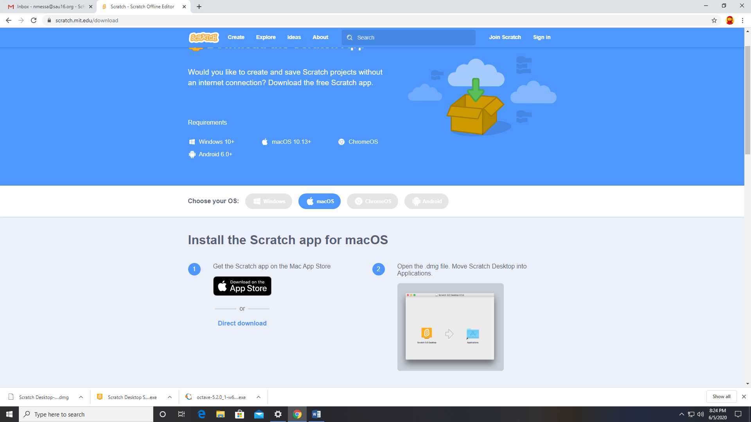

1. Select Installation Options. I chose All Users and click Install button

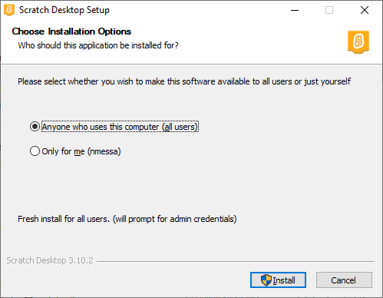

1. Click Finish and let Scratch Desktop Run

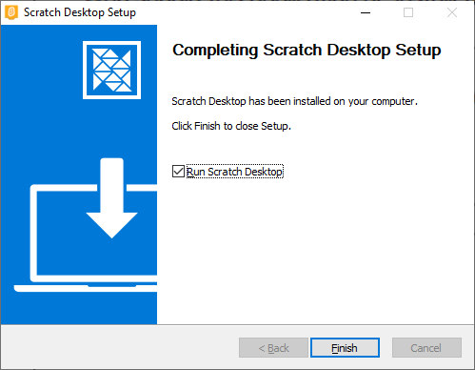

1. Now you are ready to go.

